MS WORD:

**Microsoft Word** is a [word processor](https://en.wikipedia.org/wiki/Word_processor) developed by [Microsoft](https://en.wikipedia.org/wiki/Microsoft). It was first released on October 25, 1983[[4]](https://en.wikipedia.org/wiki/Microsoft_Word#cite_note-4) under the name *Multi-Tool Word* for [Xenix](https://en.wikipedia.org/wiki/Xenix" \o "Xenix) systems.[[5]](https://en.wikipedia.org/wiki/Microsoft_Word#cite_note-PCHistory-5)[[6]](https://en.wikipedia.org/wiki/Microsoft_Word#cite_note-6)[[7]](https://en.wikipedia.org/wiki/Microsoft_Word#cite_note-7)Subsequent versions were later written for several other platforms including [IBM PCs](https://en.wikipedia.org/wiki/IBM_PC) running [DOS](https://en.wikipedia.org/wiki/DOS) (1983), [Apple Macintosh](https://en.wikipedia.org/wiki/Apple_Macintosh) running [Classic Mac OS](https://en.wikipedia.org/wiki/Classic_Mac_OS) (1985), [AT&T Unix PC](https://en.wikipedia.org/wiki/AT%26T_Unix_PC) (1985), [Atari ST](https://en.wikipedia.org/wiki/Atari_ST) (1988), [OS/2](https://en.wikipedia.org/wiki/OS/2) (1989), [Microsoft Windows](https://en.wikipedia.org/wiki/Microsoft_Windows) (1989), [SCO Unix](https://en.wikipedia.org/wiki/SCO_Unix) (1994), and [macOS](https://en.wikipedia.org/wiki/MacOS" \o "MacOS) (2001). Commercial versions of Word are licensed as a standalone product or as a component of [Microsoft Office](https://en.wikipedia.org/wiki/Microsoft_Office), [Windows RT](https://en.wikipedia.org/wiki/Windows_RT) or the discontinued [Microsoft Works suite](https://en.wikipedia.org/wiki/Microsoft_Works). [Microsoft Word Viewer](https://en.wikipedia.org/wiki/Microsoft_Word_Viewer) and [Office Online](https://en.wikipedia.org/wiki/Office_Online) are[freeware](https://en.wikipedia.org/wiki/Freeware) editions of Word with limited features.

File format

**File extensions**

Microsoft Word's native file formats are denoted either by a .doc or .docx [filename extension](https://en.wikipedia.org/wiki/Filename_extension).

Although the [.doc](https://en.wikipedia.org/wiki/Doc_(computing)) extension has been used in many different versions of Word, it actually encompasses four distinct file formats:

1. Word for DOS
2. Word for Windows 1 and 2; Word 3 and 4 for Mac OS
3. Word 6 and Word 95 for Windows; Word 6 for Mac OS
4. Word 97 and later for Windows; Word 98 and later for Mac OS

The newer .docx extension signifies the [Office Open XML](https://en.wikipedia.org/wiki/Office_Open_XML) [international standard](https://en.wikipedia.org/wiki/International_standard) for Office documents and is used by Word 2007 and later for Windows, Word 2008 and later for macOS, as well as by a growing number of applications from other vendors, including [OpenOffice.org Writer](https://en.wikipedia.org/wiki/OpenOffice.org_Writer), an [open source](https://en.wikipedia.org/wiki/Open_source) word processing program.[[42]](https://en.wikipedia.org/wiki/Microsoft_Word#cite_note-42)

**TEMPLATES:**

Several later versions of Word include the ability for users to create their own formatting templates, allowing them to define a file in which the title, heading, paragraph, and other element designs that are unique from the standard Word templates. Users can find how to do this under the Help section located near the top right corner

Title Bar:

A **title bar** is the section at the top of a window that contains the name or description of the window. Nearly all windows displayed on your computer have a **title bar**. Therefore, if several windows are tiled across the screen at one time, a user can identify each window by just glancing at the **title bar**.

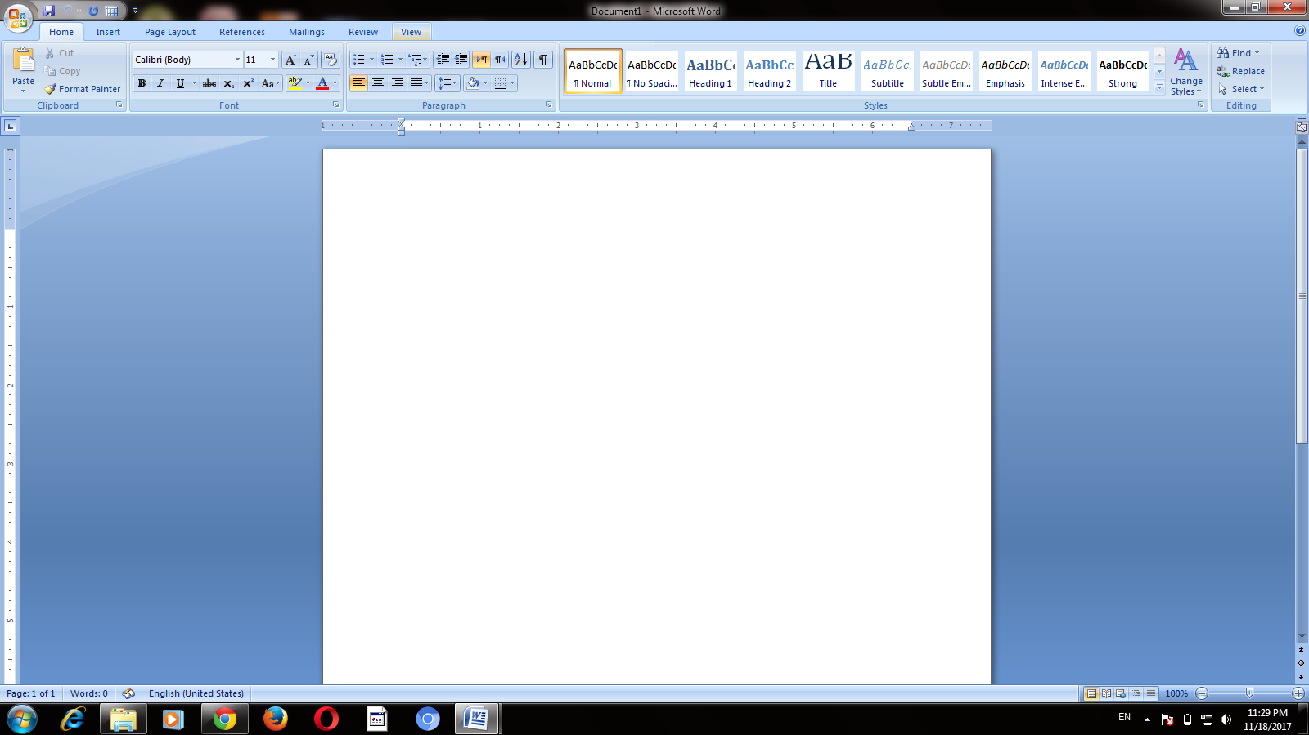

Status bar:

From Wikipedia, the free encyclopedia

[https://upload.wikimedia.org/wikipedia/commons/thumb/0/09/Emacs_statusline.png/460px-Emacs_statusline.png](https://en.wikipedia.org/wiki/File:Emacs_statusline.png)

An example of a status bar in [Emacs](https://en.wikipedia.org/wiki/Emacs" \o "Emacs)

[GTK+](https://en.wikipedia.org/wiki/GTK%2B)-based [gedit](https://en.wikipedia.org/wiki/Gedit" \o "Gedit) with a popover in the status bar.

A **status bar** is a [graphical control element](https://en.wikipedia.org/wiki/Graphical_control_element) which poses an information area typically found at the [window](https://en.wikipedia.org/wiki/Window_(computing))'s bottom.[[1]](https://en.wikipedia.org/wiki/Status_bar#cite_note-GTKtut-1) It can be divided into sections to group information. Its job is primarily to display information about the current state of its window, although some status bars have extra functionality. For example, many many [web browsers](https://en.wikipedia.org/wiki/Web_browser) have clickable sections that pop up a display of security or privacy information.

# Ribbons

In this article

* [Is this the right user interface?](https://msdn.microsoft.com/en-us/library/windows/desktop/dn742393(v=vs.85).aspx#is_this_the_right_user_interface_)
* [Design concepts](https://msdn.microsoft.com/en-us/library/windows/desktop/dn742393(v=vs.85).aspx#design_concepts)
* [Guidelines](https://msdn.microsoft.com/en-us/library/windows/desktop/dn742393(v=vs.85).aspx#guidelines)
* [Labels](https://msdn.microsoft.com/en-us/library/windows/desktop/dn742393(v=vs.85).aspx#labels)
* [Documentation](https://msdn.microsoft.com/en-us/library/windows/desktop/dn742393(v=vs.85).aspx#documentation)

Ribbons are the modern way to help users find, understand, and use commands efficiently and directly—with a minimum number of clicks, with less need to resort to trial-and-error, and without having to refer to Help.

A ribbon is a command bar that organizes a program's features into a series of tabs at the top of a window. Using a ribbon increases discoverability of features and functions, enables quicker learning of the program as a whole, and makes users feel more in control of their experience with the program. A ribbon can replace both the traditional menu bar and toolbars.

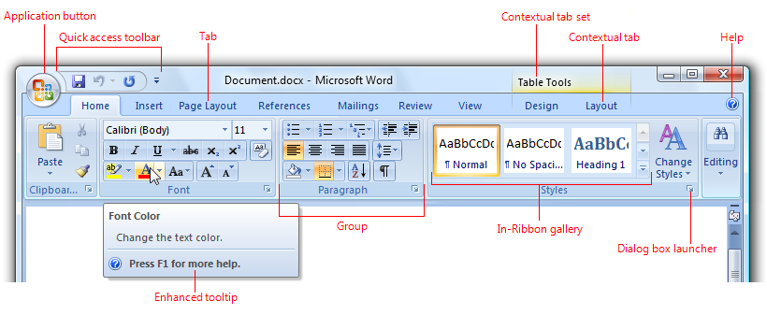

A typical ribbon.

Ribbon tabs are composed of groups, which are a labeled set of closely related commands. In addition to tabs and groups, ribbons consist of:

* An Application button, which presents a menu of commands that involve doing something to or with a document or workspace, such as file-related commands.
* A Quick Access Toolbar, which is a small, customizable toolbar that displays frequently used commands.
* Core tabs are the tabs that are always displayed.
* Contextual tabs, which are displayed only when a particular object type is selected. Tabs that are always displayed are called core tabs.
* A tab set is a collection of contextual tabs for a single object type. Because objects can have multiple types (for example, a header in a table that has a picture is three types), there can be multiple contextual tab sets displayed at a time.
* Modal tabs, which are core tabs displayed with a particular temporary mode, such as print preview.
* Galleries, which are lists of commands or options presented graphically. A results-based gallery illustrates the effect of the commands or options instead of the commands themselves. An in-ribbon gallery is displayed within a ribbon, as opposed to a pop-up window.
* Enhanced tooltips, which concisely explain their associated commands and give the shortcut keys. They may also include graphics and references to Help. Enhanced tooltips reduce the need for command-related Help.
* Dialog box launchers, which are buttons at the bottom of some groups that open dialog boxes containing features related to the group.

Ribbons were originally introduced with Microsoft Office 2007. To learn why Office needs to use ribbons and the many problems using a ribbon solves, see [The Story of the Ribbon](http://blogs.msdn.com/jensenh/archive/2008/03/12/the-story-of-the-ribbon.aspx).